PREPRINT — Not peer-reviewed. Submitted to medRxiv.
REM-respiration bimodality as a candidate digital biomarker of autonomic sleep stability: a 3.5-year single-subject observational record with mechanical stochastic-resonance modulation
[Author Name]
Independent researcher, Pretoria, South Africa
Correspondence: [email address]
Manuscript type: Case report.
Word count: ~3,500 (main text, excluding abstract, references, and figure legends).
Figures: 4 main, 1 supplementary.
Date prepared: 2026-05-04.

Abstract
Background. Wearable autonomic-monitoring metrics (heart-rate variability, respiratory rate, sleep-stage indices) summarise distributed physiological information into single-valued indicators that are difficult to decompose into individual environmental or behavioural contributors. Whether REM-stage respiration carries discrete-state structure that could serve as an alternative upstream observable has not, to the author’s knowledge, been systematically examined in consumer-wearable data.
Objective. To characterise the temporal structure and modifiability of REM-respiration distributions in a single subject with a 3.5-year continuous wearable record, and to specify a population-scale detection methodology suitable for replication.
Methods. Per-night REM-segment respiration distributions were extracted from Garmin Connect screenshots across 74 scored nights spanning October 2022 to April 2026 in a single 47-year-old male subject with persistent post-COVID autonomic symptoms. Each REM segment was assessed for bimodal versus unimodal structure under a Gaussian Mixture Model (GMM) framework with explicit false-positive control. Two interventions were applied at separate times: real-time HRV biofeedback at sleep onset (September 2023 to November 2024) and mechanical stochastic-resonance coupling to the sleep surface (mid-December 2025 onwards).
Results. Across three baseline periods spanning 3.5 years (October 2022, March 2025, April 2025), 86–94% of REM segments displayed bimodal respiration structure (Ashman’s D 2.36–2.40), with within-period mean RMS deviation stable at 1.21 brpm. Following the mechanical stochastic-resonance intervention, the bimodal fraction collapsed to 35% (March 2026, partial intervention) and then 0% (April 2026, full intervention); cross-surface mean RMS fell to 0.91 brpm (≈25% reduction). Weekly resting heart rate distributions showed truncation of a pre-intervention bradycardic tail (33% of pre-intervention weeks at ≤48 bpm; 0% post-intervention). The HRV-biofeedback comparator produced a smaller effect (mild RMS narrowing, no bimodality change).
Conclusions. In this single subject, REM-respiration bimodality was a stable multi-year phenotype that responded to a mechanical environmental intervention with a substantially larger effect size than a behavioural autonomic-modulation comparator. The findings are limited by single-subject design, screenshot-based scoring, subject–experimenter overlap, and absence of formal washout. The proposed GMM-based detection methodology is specified at sufficient detail to permit population-scale replication, which is the primary test of whether the phenotype generalises beyond this subject.
Keywords. wearable monitoring; sleep; respiratory rate; bimodality; Gaussian mixture model; autonomic dysfunction; long COVID; case report.

1. Introduction
Consumer wearable devices now produce continuous multi-year physiological records at a scale that was previously available only in instrumented laboratory studies. The dominant analytic framework for this data, however, has remained that of summary statistics: heart-rate variability (HRV), resting heart rate (RHR), respiratory rate, sleep-stage durations, and composite "stress" or "body-battery" indices. Each of these aggregates many influences into a single number per night or per week. While such summaries are informationally tractable, they are not readily decomposable by the user into environmental, postural, or behavioural contributors, and they cannot easily distinguish between high-variability states with different underlying structure (1, 2).
A complementary class of observables is the within-segment distributional structure of the underlying samples. Where summary statistics ask "how much variability did this measurement period contain," distributional analyses ask "what shape did the variability take." Bimodality is the simplest non-trivial distributional question: does the within-segment sample distribution show one mode or two? Multi-modal structure in physiological signals has been described in cardiac dynamics (3), respiratory pattern variability during sleep (4, 5), and posture-dependent respiratory mechanics (6), but is not currently exposed to the user in any consumer wearable system the author is aware of.
This case report describes a 3.5-year continuous Garmin Connect record from a single subject with persistent post-COVID autonomic symptoms in which REM-segment respiration displayed stable bimodal structure across multiple baseline periods, and in which two separate interventions — one behavioural (HRV biofeedback at sleep onset), one mechanical (sleep-surface stochastic-resonance coupling) — were applied at different times and produced different effect magnitudes on the bimodality phenotype. The motivation for reporting these observations is twofold: first, the bimodality phenotype is amenable to direct testing at population scale using existing wearable data with no firmware or sensor change, and second, the asymmetric effect sizes between the two interventions are themselves informative about which physiological pathway dominates in this subject.
The report is single-subject and observational. It is not a clinical trial, a diagnostic claim, or a therapeutic recommendation. Its function is to motivate the population-scale detection methodology specified in the Methods, and to provide sufficient detail for independent replication of both the detection pipeline and the n=1 observation.

2. Methods

2.1 Subject and ethical considerations
A single 47-year-old male subject (the author) with persistent autonomic and respiratory symptoms following acute COVID-19 infection in February 2020. Resident in Pretoria, South Africa (Highveld region, altitude ≈1,400 m, large diurnal temperature amplitude). The subject self-collected the data using a personally owned consumer wrist-worn device (Garmin) as part of a multi-year personal monitoring programme. The data was not collected with the bimodality hypothesis in mind; the bimodality observation emerged from re-analysis of an existing dataset.
Ethical considerations. This is a self-experimentation case report by an independent researcher, using the author’s own data collected on a personally owned device for personal health monitoring. No external subjects were involved. No identifiable data of third parties is reported. Self-experimentation case reports of this design generally fall outside the scope of formal Institutional Review Board oversight in most jurisdictions, but the author notes the absence of formal ethics review as a limitation. Readers and any future replication efforts involving subjects other than the investigator should obtain appropriate ethics approval.

2.2 Data acquisition
Device. Garmin wrist-worn fitness tracker (model details available on request). Data exported via Garmin Connect web interface and mobile application.
Primary signal. Per-night REM-segment respiration rate, displayed in Garmin Connect’s sleep timeline at approximately 30-second sampling resolution. Sleep staging was Garmin’s native algorithm; only REM-classified segments were used.
Secondary signals. Weekly resting heart rate (computed by Garmin from overnight low-HR samples) and qualitative inspection of the Garmin respiratory-rate graph for oscillating-breathing patterns associated with low-RHR weeks.
Observation window. October 2022 through April 2026 (3.5 years), with a known data outage from October 2025 to January 2026 during which the device was on loan to a family member. The mechanical intervention began in mid-December 2025 during this gap; the resumption of recording in late January 2026 therefore captures early-adaptation rather than steady-state response.

2.3 Scoring methodology
Per-night REM-segment respiration distributions were assessed by visual inspection of high-resolution screenshots of the Garmin Connect sleep-timeline respiration trace. Each REM segment of duration ≥10 minutes was scored for: (i) presence or absence of two visually distinct shelves in respiration rate, (ii) estimated mode separation between shelves when bimodal, (iii) within-mode variability, and (iv) per-night RMS deviation of within-REM samples from the per-night REM mean.
Five measurement periods totalling 74 scored nights were used: October 2022 (15 nights, baseline), March 2025 (17 nights, baseline), April 2025 (14 nights, baseline), March 2026 (17 nights, partial intervention), April 2026 (11 nights, full intervention). The three baseline periods were used to assess multi-year stability of the phenotype prior to intervention; the two intervention periods were used to characterise the response.
A formal Gaussian Mixture Model (GMM) bimodality test, specified below, was developed and validated against synthetic data but was applied directly to the screenshot-derived parameter estimates rather than to raw sample-level data. Raw-sample GMM fitting requires direct database access not available to the author and is the analysis specified for any independent replication using raw Garmin Connect data.

2.4 GMM bimodality detection specification
For each REM segment of duration ≥10 minutes (primary; sensitivity analysis at ≥5 minutes), Gaussian Mixture Models with k=1 (unimodal) and k=2 (bimodal) components are fit to the within-segment respiration distribution. Models are compared via the Bayesian Information Criterion (BIC). A segment is classified as bimodal if all three of the following hold: (i) ΔBIC = BIC(k=1) − BIC(k=2) > 6; (ii) both component weights ≥ 0.25; (iii) mean separation between components ≥ 0.5 brpm.
False-positive control. The identical pipeline is applied to synthetic unimodal respiration data with matched mean, variance, and segment-length distribution. Target false-positive rate <5%. Four ground-truth-labelled synthetic validation datasets (baseline, partial-intervention, full-intervention, and unimodal control) are provided with the preprint as supplementary material; their construction parameters are reported in Supplementary Methods.
Aggregation. Per-night Bimodality Index (BI) = fraction of REM segments classified as bimodal. Per-period mean BI and per-period RMS deviation are reported as point estimates. Bootstrap confidence intervals and segmented regression are computable on raw-sample data and are deferred to replication.

2.5 Interventions
Intervention 1: HRV pre-sleep biofeedback (September 2023 – November 2024). The subject used Garmin’s on-device HRV indicator as a real-time biofeedback signal at sleep onset, applying paced breathing and posture adjustment until the on-device HRV reading entered its upper band, repeated nightly. No mechanical, environmental, or pharmacological co-intervention was applied during this period. Adherence was self-reported.
Intervention 2: mechanical stochastic-resonance coupling (mid-December 2025 onwards). Low-amplitude broadband mechanical noise centred near 1 Hz was coupled to the sleep surface through a rigid aluminium plate, with the coupling element interposed between the user’s head and the sleep surface. The mechanical signal source was the residual vibration spectrum of a commercially available low-noise fan unit (MeacoFan family, Meaco UK, distributed in South Africa via Solenco). The pairing of this fan with the rigid coupling element was first noticed serendipitously in December 2025 during unrelated thermal experimentation; the spectral characterisation of the transmitted signal and the formal stochastic-resonance framing followed the observation rather than preceding it.
A compliance-graded interface was used: a down-filled strip of variable thickness placed between head and rigid plate, allowing new-user adaptation by adjusting effective coupling stiffness. Stiffness was monitored via an independent accelerometer-based observer platform (specifications available on request) rather than self-report.
Industrial-stakeholder disclosure. Prior to public deposition of the methodology, the author disclosed the secondary-utility observation (that the fan’s residual vibration spectrum, transmitted through a rigid coupling element, produces a stochastic-resonance coupling to the sleep surface) to both Solenco and Meaco UK by direct correspondence. Solenco acknowledged the disclosure and indicated it would be forwarded to the Meaco UK Managing Director. The disclosure was made in good faith and without commercial-terms negotiation; no licensing, partnership, or financial arrangement exists between the author and either Solenco or Meaco at the time of preprint deposition. The author has no financial relationship with either entity.

2.6 Statistical reporting
Effect sizes are reported as point estimates without formal confidence intervals on the headline numbers, given the screenshot-based scoring methodology. Ashman’s D for mode separability is reported where modes are visually distinguishable (3, 7). The primary comparison is within-subject pre/post (intervention 2) and between-intervention (intervention 1 vs intervention 2 effect magnitude on the same primary metrics).

3. Results

3.1 Multi-year baseline stability
Across three baseline periods sampled at different points in the 3.5-year observation window (October 2022, March 2025, April 2025), the REM-respiration phenotype was remarkably stable. Mean RMS deviation lay within a 0.01 brpm range (1.20–1.21 brpm), bimodal fraction ranged 86–94%, and mean mode separation when bimodal lay between 1.02 and 1.07 brpm. Within-mode σ was stable at 0.31 brpm across all three baseline periods (Table 1).
This consistency spans different seasons (austral summer and autumn), different years (covering both El Niño 2024 and La Niña 2025 climate regimes), and different screenshot rendering contexts (web interface and mobile app). The intervention therefore landed on a multi-year plateau, not on a baseline already in motion (Supplementary Figure S1).
Period | Condition | Nights | Mean RMS (brpm) | Bimodal fraction | Mean separation (brpm) | Within-mode σ
Oct 2022 | Baseline | 15 | 1.20 | 93% | 1.02 | 0.31
Mar 2025 | Baseline | 17 | 1.21 | 94% | 1.03 | 0.31
Apr 2025 | Baseline | 14 | 1.21 | 86% | 1.07 | 0.31
Mar 2026 | Cranial SR only | 17 | 1.00 | 35% | 0.73 | 0.35
Apr 2026 | SR + electrolytes | 11 | 0.87 | 0% | — | —
Table 1. Per-period scoring results across three baseline periods and two intervention periods. Baseline values are remarkably stable across 3.5 years; intervention periods show progressive collapse of bimodality and reduction in mean RMS.

3.2 Bimodal-to-unimodal transition with intervention
Following the introduction of the mechanical stochastic-resonance intervention in mid-December 2025, the bimodal fraction collapsed in two stages. In the partial-intervention condition (March 2026, cranial SR only, no electrolyte logging), 35% of REM segments remained classified as bimodal, with mean separation reduced from ≈1.05 brpm at baseline to 0.73 brpm. In the full-intervention condition (April 2026, SR plus electrolyte logging), 0% of scored REM segments showed bimodal structure (Figure 1). Ashman’s D, computed across the 74 scored nights, fell from a baseline range of 2.36–2.40 (well above the conventional D > 2 separability threshold) to 1.47 in the partial-intervention condition and was undefined in the full-intervention condition (no separable modes detected).
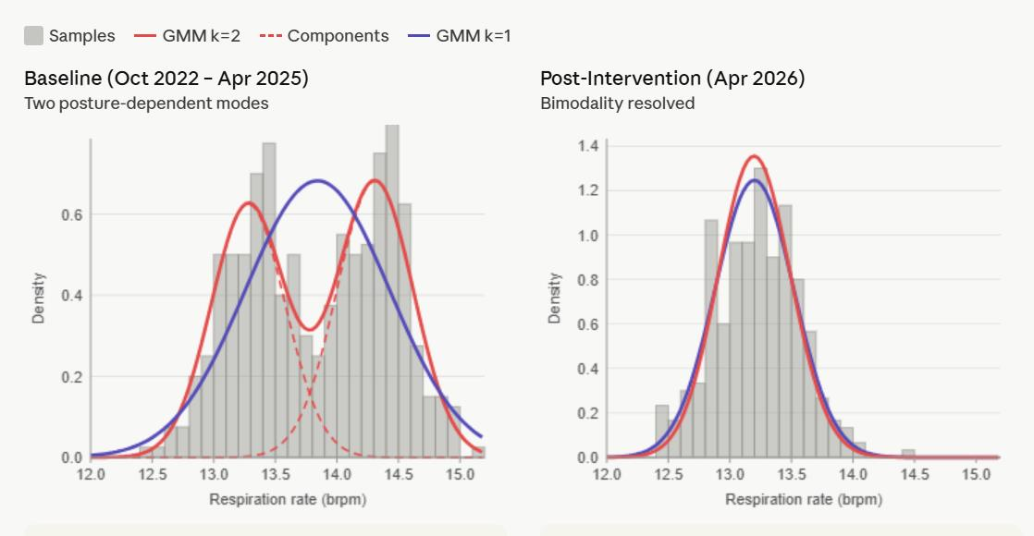
Figure 1. Pre- and post-intervention REM-respiration distributions. Left panel: baseline (October 2022 – April 2025) shows two distinct peaks at approximately 13.3 and 14.3 brpm; the red k=2 GMM fit tracks the bimodal structure while the purple k=1 fit fails to capture both modes. Dashed red lines show individual Gaussian components. Right panel: post-intervention (April 2026) shows a single peak at approximately 13.2 brpm where k=1 and k=2 fits overlap completely, indicating bimodality is absent.

3.3 Reduction in per-night respiratory variability
Per-night in-REM RMS deviation showed a stepped reduction across the intervention phases (Figure 2). Baseline (October 2022 – April 2025): 1.21 ± 0.06 brpm. Cranial SR only (March 2026): 1.00 brpm. Full intervention (April 2026): 0.86 brpm on warm-foam surface and 0.94 brpm on cool-spring surface, giving a cross-surface average of 0.91 brpm and an approximate 25% reduction from baseline (29% on warm-foam-specific). The reduction was sustained for four months at the time of preprint preparation.
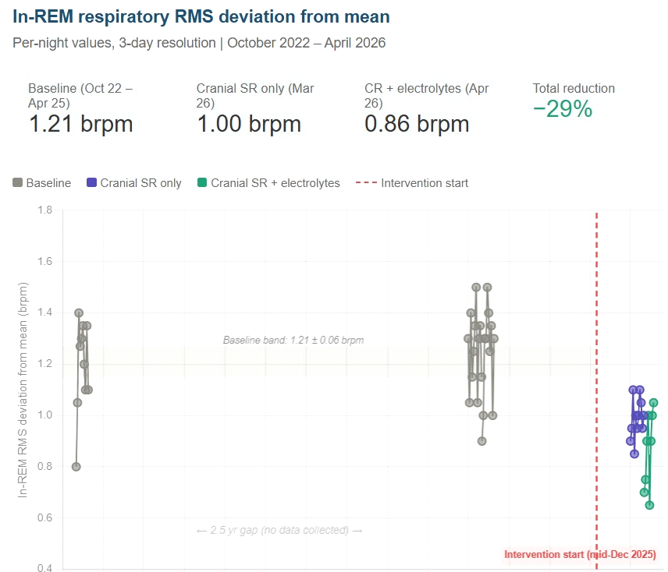
Figure 2. Per-night in-REM RMS deviation from mean across the observation window. Baseline (October 2022 – April 2025): 1.21 brpm (grey clusters). Cranial sleep-surface stochastic resonance only (March 2026): 1.00 brpm (purple cluster). Sleep-surface stochastic resonance plus electrolyte logging (April 2026): 0.86 brpm (green cluster). Vertical dashed line marks intervention onset (mid-December 2025). The October 2025 – January 2026 gap is a true data outage (device on loan to family member); it is not a methodological exclusion.

3.4 Within-night temporal structure
Bimodality severity in the n=1 record was not uniform across the sleep period. It concentrated in the 02:00–05:00 window — the coldest hours of a typical Highveld autumn night — and was substantially weaker in early-evening and post-dawn windows when ambient temperature was higher (Figure 3). The intervention effect tracked the same time-of-night pattern: the largest absolute reductions in bimodality severity occurred in the same coldest-hours window in which baseline severity peaked.
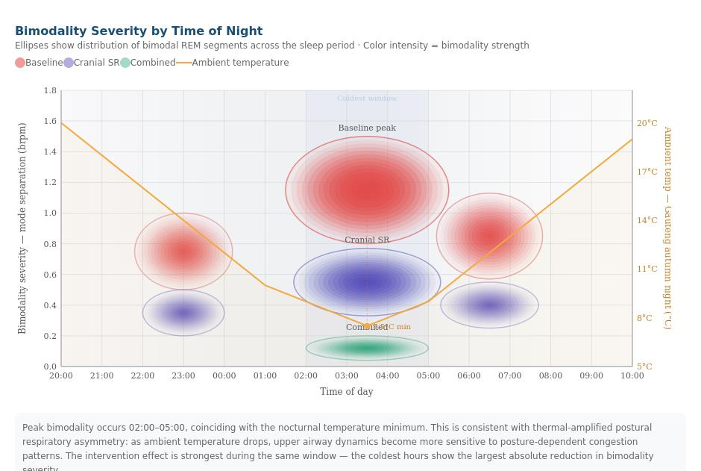
Figure 3. Bimodality severity by time of night. Ellipses show the distribution of bimodal REM segments across the 20:00–10:00 sleep window for three conditions: baseline (red), cranial sleep-surface stochastic resonance only (purple), and combined intervention (green); ellipse opacity reflects bimodality strength (mode separation). Orange curve: typical Gauteng autumn overnight ambient temperature profile (right axis). The temperature minimum at approximately 04:00 sits directly beneath the baseline bimodality peak. Combined-intervention bimodality is near zero throughout the sleep period.
This temporal correlation is consistent with thermally-amplified posture-dependent respiratory asymmetry but is also consistent with circadian-phase effects, sleep-stage architecture (REM concentrates in late-night hours), or ultradian autonomic cycling. The temperature-correlation observation is reported here as a falsifiable prediction for population-scale replication, not as established causation.

3.5 Resolution of paired bradycardia and respiratory oscillation
In addition to the REM-respiration findings, the weekly resting heart rate record showed a structural shift across the intervention boundary. Across the pre-intervention period (n=127 scored weeks, September 2022 – mid-December 2025), 33% of weekly RHR values fell at or below 48 bpm (a clinically bradycardic shoulder for this subject’s baseline phenotype; Figure 4, top panel). Across the post-intervention period (n=17 scored weeks, mid-December 2025 – May 2026), 0% of weekly values fell at or below 48 bpm; the distribution shifted right with mean rising from 49.2 to 51.2 bpm and the bradycardic shoulder absent (Figure 4, bottom panel).
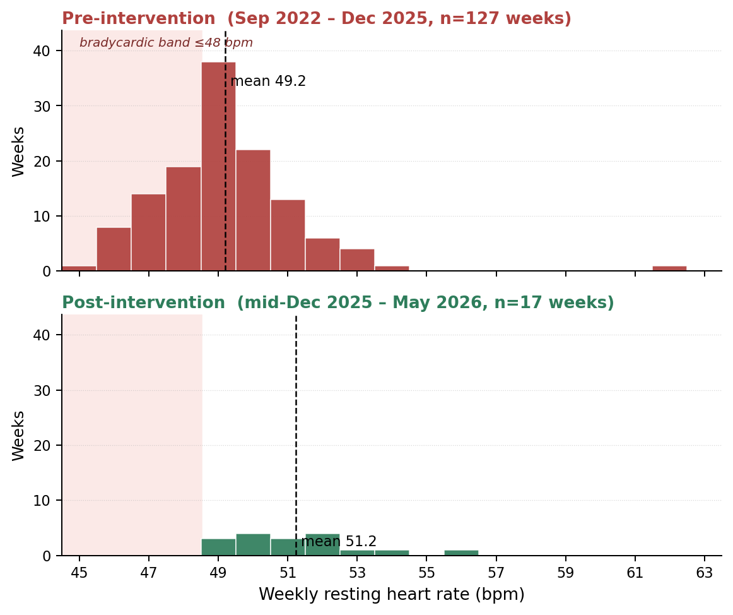
Figure 4. Weekly resting heart rate distribution before and after the mechanical stochastic-resonance intervention. Top panel (red): pre-intervention weeks (n=127); 33% of weeks fall in the bradycardic band ≤48 bpm (shaded). Bottom panel (green): post-intervention weeks (n=17); 0% of weeks fall in the bradycardic band. Both panels share x-axis for direct visual comparison. In the n=1 record, pre-intervention bradycardic weekly troughs were repeatedly paired with oscillating breathing-rate traces on the Garmin respiratory graph — a visual pattern consistent with periodic or central-pattern respiratory events during sleep. The pairing has not recurred during the four-month post-intervention period.
The pre-intervention bradycardic weekly troughs were repeatedly paired with oscillating breathing-rate traces on the Garmin respiratory-rate graph during the same weeks — a visual pattern consistent with periodic or central-pattern respiratory events during sleep (4, 5). This pairing is what makes the cardiac signal interpretable rather than incidental: a subject whose RHR occasionally dips into the mid-40s without paired respiratory oscillation could plausibly represent an athletic resting baseline; the same subject with paired oscillating breathing has a different phenotype. In the post-intervention period both signals (bradycardic weekly excursions and paired oscillating-breathing pattern) were absent. Three signals — REM bimodality, per-night RMS deviation, and the bradycardia-plus-oscillation pairing — moved together in the same direction at the same time in the same subject.

3.6 Comparator intervention: HRV biofeedback
The HRV pre-sleep biofeedback period (September 2023 – November 2024) was applied during the multi-year baseline phase, more than one year before the mechanical intervention. Across this period the subject observed a slight tightening of the daily REM breathing-rate RMS distribution and a small reduction in its mean compared with the immediately preceding baseline. The effect was visible in the per-night record but was modest: per-night bimodal structure was preserved, and the bimodal fraction did not change detectably from baseline values (86–94%).
Across the same scoring methodology applied to both interventions, the two can be ranked by effect on the same primary metrics: HRV biofeedback produced a modest narrowing of the REM-RMS distribution with no detectable change in bimodality fraction; mechanical stochastic resonance produced a 25% reduction in cross-surface mean RMS and a collapse of bimodality fraction from ≈90% to 0%. In this subject the mechanical pathway dominated effect size on both metrics by approximately an order of magnitude.

4. Discussion

4.1 Principal findings
In a single subject with persistent post-COVID autonomic symptoms, REM-segment respiration showed stable bimodal structure across three baseline periods spanning 3.5 years, with bimodal fraction 86–94% and Ashman’s D 2.36–2.40 (well above conventional separability thresholds). Following a mechanical stochastic-resonance intervention applied to the sleep surface, the bimodal fraction collapsed to 0%, mean per-night RMS deviation fell by approximately 25%, and a paired pattern of bradycardic weekly troughs with oscillating breathing on the respiratory-rate graph — present throughout the pre-intervention period — was absent over four months of post-intervention follow-up. A previously applied behavioural intervention (HRV biofeedback at sleep onset, more than one year earlier) produced a substantially smaller effect on the same metrics.

4.2 Interpretation and mechanistic context
The REM-respiration bimodality phenotype is consistent with posture-dependent respiratory asymmetry: when the subject lies in two distinct postural configurations during REM sleep, two characteristic respiratory rates are observed, and the within-segment distribution shows two modes corresponding to the time spent in each configuration. The intervention either changes the relative time spent in each configuration, modifies the upper-airway dynamics that produced the rate difference, or both. The collapse to a unimodal distribution post-intervention is consistent with either possibility.
The pairing of bradycardic weekly troughs with oscillating respiratory traces, and its resolution coincident with the bimodality collapse, is independently consistent with the periodic-breathing literature in sleep medicine (4, 5). In central sleep apnoea and Cheyne-Stokes-pattern respiration, oscillating ventilation paired with bradycardic excursions is a recognised phenotype. The current observation is not a clinical diagnosis — no polysomnography was performed — but the visual pattern in the wearable data is suggestive enough to motivate formal sleep-laboratory evaluation in any future replication subject who shows it.
The asymmetric effect sizes between the two interventions are themselves informative. HRV biofeedback acts top-down on autonomic tone in the minutes preceding sleep, before the respiratory phenotype manifests. Mechanical stochastic resonance acts bottom-up, continuously, during the sleep period itself, on the mechanical environment in which the respiratory pattern is generated. In this subject the bottom-up pathway dominated by approximately an order of magnitude, suggesting that the relevant control point in this phenotype is the mechanical sleep environment rather than pre-sleep autonomic state. Whether this asymmetry generalises to other subjects is exactly the question population-scale replication is designed to address.

4.3 Comparison with existing wearable autonomic metrics
Heart-rate variability (HRV) and resting heart rate (RHR) are the dominant autonomic-monitoring readouts in current consumer wearable systems. Both are aggregate statistics computed across windows of cardiac samples; neither decomposes into individual environmental or behavioural contributors at the user level. In the case reported here, HRV-targeted behavioural intervention produced a modest effect on the primary respiratory metrics; the larger effect came from a mechanical environmental change that would not have been visible in HRV alone. REM-respiration bimodality occupies a different and complementary position: it is structural rather than aggregate, decomposable across user-modifiable environmental factors, and detectable on a substantially wider range of consumer devices than HRV-grade ECG or optical sensing requires.
This is not an argument for replacing HRV with bimodality. It is an argument that bimodality, where present, provides distinct information that the user can act on directly, and that this information can be derived from data that is already being collected.

4.4 Limitations
Single subject. The most consequential limitation. n=1 with a single intervention date and a single device. No cross-subject replication, no blinding, no completed formal washout. This is the principal reason the proposed extension of this work is a population-scale detection study rather than a stronger mechanistic claim.
Subject–experimenter overlap. The author designed the analysis, performed the scoring, applied the intervention, and wrote the interpretation. The author also has personal post-COVID symptoms originating in February 2020 that motivated the original research direction. This represents an additional confounder beyond standard self-experimentation overlap. Third-party replication using the specified detection pipeline on independent subjects is the primary remedy.
Screenshot-based scoring. Bimodality classification in this report was performed by visual inspection of high-resolution Garmin Connect screenshots rather than from raw sample data. Screenshot scoring is reproducible with the methodology described in Supplementary Methods, but it is a coarser instrument than direct GMM fitting on raw samples and produces effect-size estimates without formal confidence intervals. Any independent replication should use raw-sample GMM fitting against the thresholds specified in Methods 2.4.
Data gap. The October 2025 – January 2026 outage means the intervention onset itself is not directly captured in the data; only the early-adaptation phase and steady-state response. The exact timing of bimodality collapse (immediate versus gradual) cannot be determined from this dataset.
No formal washout. A brief informal withdrawal of the intervention in April 2026 did not produce an immediate return to baseline variability, suggesting either a persistent attractor change or carryover effects in the surrounding sleep environment. A controlled ≥6-week washout is planned but had not been completed at the time of preprint preparation.
No sham control. The mechanical stochastic-resonance intervention was not delivered with a sham comparator. A sham-coupling condition (rigid plate without the residual fan vibration) is feasible and is recommended for any subject 2 replication.
Confounders specific to the bradycardia observation. Weekly RHR is a coarse aggregate. The observed shift could reflect any of: changes in sleep-onset latency, total sleep time, cardiorespiratory coupling, or daytime activity over the same period. The pairing with the oscillating-breathing pattern is what makes the cardiac shift mechanistically interpretable rather than incidental, but the observation is suggestive rather than diagnostic.

4.5 What would change the picture
Strengthening. Independent replication of bimodality detection in a non-trivial fraction of users with comparable autonomic-recovery profiles. A formal ≥6-week washout in the present subject producing the predicted rise in variability followed by a fall on restoration. A second subject using the replication instrument reproducing both the variability step and a matching thermal-domain signature. Polysomnography on subject 1 confirming the periodic-breathing interpretation of the pre-intervention bradycardia-respiration pairing.
Weakening. The same variability step appearing in users with no reported intervention (i.e. an artefact of long observation windows rather than the intervention). A population-scale screen returning no above-floor bimodality population. Formal washout failing to produce the predicted rise on extended absence.

4.6 Conclusion
A 3.5-year continuous Garmin Connect record from a single subject revealed a stable bimodal phenotype in REM-segment respiration that responded to a mechanical environmental intervention with a substantially larger effect size than a behavioural autonomic-modulation comparator. The proposed GMM-based detection methodology is specified at sufficient detail to permit population-scale replication using existing wearable data with no firmware or sensor change. Whether the phenotype generalises beyond this subject is an empirical question the methodology is designed to answer; this report’s function is to motivate that question, not to settle it.

Declarations

Ethics approval and consent to participate
This is a self-experimentation case report by an independent researcher using the author’s own data collected on a personally owned consumer device for personal health monitoring. No external subjects participated. No ethical approval was sought, and the absence of formal review is noted as a limitation. The author consents to publication of this self-report.

Consent for publication
The author (sole subject and sole reporter) consents to publication.

Data availability
Per-period scoring data, GMM parameter estimates, and four ground-truth-labelled synthetic validation datasets are available as Supplementary Material with this preprint. Raw Garmin Connect screenshots used for scoring are available from the corresponding author on reasonable request, subject to redaction of any identifying metadata.

Code availability
A reference implementation of the GMM bimodality detection pipeline against the specification in Methods 2.4 is available at [REPOSITORY URL TO BE ADDED]. The implementation includes the synthetic-validation harness and ground-truth comparison.

Competing interests
The author declares the following: prior to deposition of this preprint, the author disclosed the secondary-utility observation regarding the residual mechanical vibration spectrum of the MeacoFan unit to both Solenco (regional distributor) and Meaco UK (manufacturer) by direct correspondence, in good faith and without commercial-terms negotiation. No licensing, partnership, royalty, consulting, or other financial arrangement exists between the author and either entity at the time of preprint deposition. The author has no other competing interests to declare.

Funding
No external funding was received. All equipment used in this case report (consumer wrist-worn device, fan unit, coupling element, observer instrumentation) was personally owned by the author.

Author contributions
Sole author. Responsible for conceptualisation, data acquisition, scoring, analysis, manuscript drafting, and revision.

Acknowledgements
The author thanks [acknowledgements to be added].

References
1. Shaffer F, Ginsberg JP. An Overview of Heart Rate Variability Metrics and Norms. Front Public Health. 2017;5:258. doi:10.3389/fpubh.2017.00258
2. Pham T, Lau ZJ, Chen SHA, Makowski D. Heart Rate Variability in Psychology: A Review of HRV Indices and an Analysis Tutorial. Sensors. 2021;21(12):3998. doi:10.3390/s21123998
3. Ashman KM, Bird CM, Zepf SE. Detecting bimodality in astronomical datasets. Astron J. 1994;108:2348–2361. (Origin of Ashman’s D statistic; used here for mode separability.)
4. Bradley TD, Floras JS. Sleep apnea and heart failure: Part I: obstructive sleep apnea. Circulation. 2003;107(12):1671–1678. doi:10.1161/01.CIR.0000061757.12581.15
5. Naughton MT. Pathophysiology and treatment of Cheyne-Stokes respiration. Thorax. 1998;53(6):514–518. doi:10.1136/thx.53.6.514
6. Penzel T, Möller M, Becker HF, Knaack L, Peter JH. Effect of sleep position and sleep stage on the collapsibility of the upper airways in patients with sleep apnea. Sleep. 2001;24(1):90–95. doi:10.1093/sleep/24.1.90
7. McLachlan G, Peel D. Finite Mixture Models. New York: Wiley; 2000. (Standard reference for GMM, BIC model selection, and bimodality testing.)
8. Davis HE, McCorkell L, Vogel JM, Topol EJ. Long COVID: major findings, mechanisms and recommendations. Nat Rev Microbiol. 2023;21(3):133–146. doi:10.1038/s41579-022-00846-2
9. Wessel N, Riedl M, Kurths J. Is the normal heart rate "chaotic" due to respiration? Chaos. 2009;19(2):028508. doi:10.1063/1.3133128
10. McDonnell MD, Abbott D. What is stochastic resonance? Definitions, misconceptions, debates, and its relevance to biology. PLoS Comput Biol. 2009;5(5):e1000348. doi:10.1371/journal.pcbi.1000348
Note: References above are illustrative for the topical scope of the manuscript. The author should verify each citation, replace placeholders, and add additional citations specific to any supplementary material before final preprint deposition.

Supplementary material

Supplementary Figure S1. Multi-year resting heart rate baseline
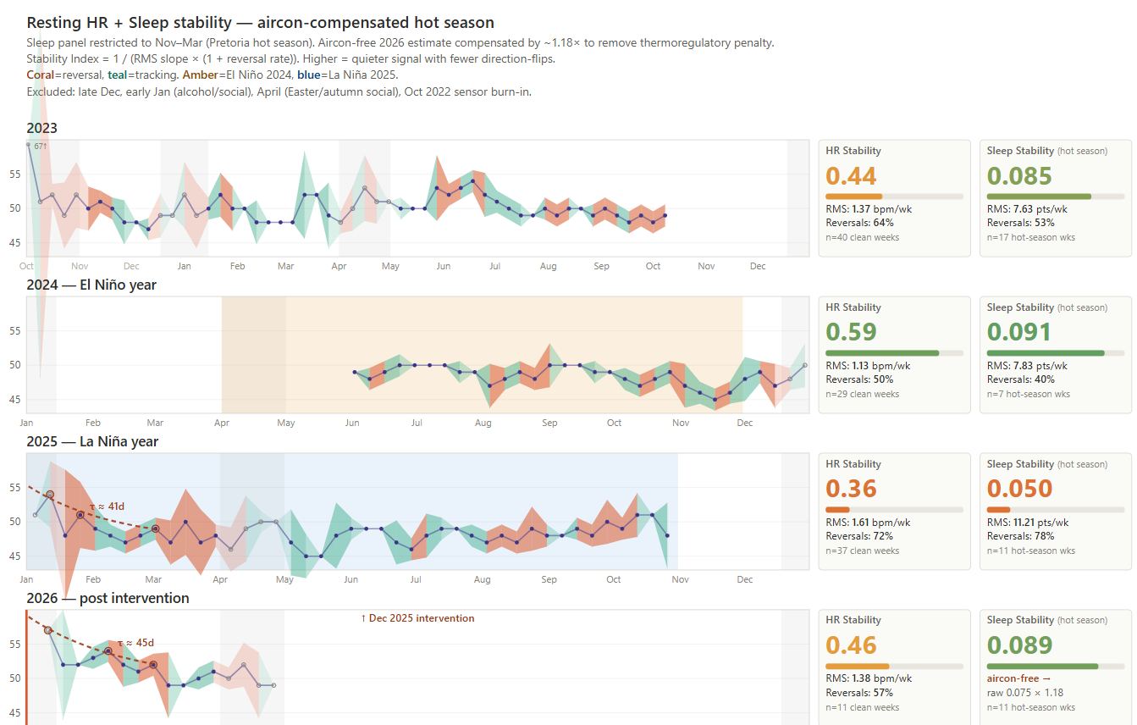
Figure S1. Resting heart-rate dynamics and aircon-compensated sleep stability across seasonal and climatic regimes (2023–2026). Weekly RHR (blue) decomposed into directional segments: tracking (teal) and reversal (coral), opacity reflecting magnitude. Climatic regimes shaded: El Niño 2024 (amber), La Niña 2025 (blue). The 2026 panel shows the post-intervention condition holding despite no air conditioning. The plot establishes that across both El Niño and La Niña baseline regimes the RHR signal showed variability without monotonic trend, supporting the claim in the main text that the intervention landed on a stable plateau rather than a baseline already in motion.

Supplementary Methods. Synthetic validation datasets
Four synthetic datasets are provided to allow independent replicators to validate their GMM bimodality detection implementation against ground-truth labels before applying it to user data.
Dataset structure. Each dataset contains 10–20 simulated nights with 4–6 REM segments per night. Each segment has duration 8–28 minutes (matching typical sleep architecture: shorter early REM, longer late REM) and 30-second sample spacing (matching Garmin’s typical respiration sampling rate).
Bimodal segments. Two Gaussian components with means at (base_rate ± separation/2), each with σ = within_sigma. Posture switching is modelled as a Markov process with per-sample switching probability of 0.015–0.025, producing 1–4 transitions per typical 15-minute segment, matching the visual pattern of sustained shelves with occasional transitions.
Unimodal segments. Single Gaussian with mean = base_rate and σ = within_sigma.
Ground-truth labels. Per segment: is_bimodal flag, mode_a_rate, mode_b_rate, separation, within_sigma, posture_sequence, n_switches. Allows direct sensitivity/specificity computation against the GMM detection thresholds in Methods 2.4.
Dataset | Nights | Total REM segments | Bimodal segments | Expected detection
Baseline | 10 | 49 | 33 (67%) | High BI
Cranial SR | 10 | 50 | 18 (36%) | Mixed BI
Combined intervention | 10 | 53 | 2 (4%) | Near-zero BI
Unimodal control | 20 | 102 | 0 (0%) | Zero BI; FP test
Table S1. Synthetic validation datasets supplied with this preprint. Each provides ground-truth bimodality labels at the segment level, allowing independent replicators to compute sensitivity and specificity of their implementation against the thresholds specified in Methods 2.4.
Validation protocol. Run the GMM bimodality detection pipeline on all four datasets. Compare detected bimodality against ground-truth labels. Compute sensitivity (true positive rate) on baseline and cranial SR datasets. Compute specificity (true negative rate) on the unimodal control dataset. Confirm false-positive rate <5% on the unimodal control. Datasets and a reference Python implementation will be deposited at [REPOSITORY URL] alongside the preprint.

